Catbrook Educational Trust
Charter

Purpose
The Catbrook Educational Trust (“CET” or the “Trust”) is established under Charity Commission scheme reference C26/04 case number 187611 (charity number 119479), which governs the activities of the Trust overall.
The purpose of this Charter is to set out the objectives of the Trust and how the Trustees will meet those objectives.
The objective of the CET is to promote the education (including social and physical development) of persons who are under the age of 25 and are or have been resident in the catchment area of the former Catbrook School. The catchment area includes the villages of Catbrook, Whitelye, Broadstone, Cicelyford, Parkhouse, Trelleck Grange, Botany Bay as shown in Annex A.
The CET’s funds originated from the sale of the old Catbrook village school in 1997 and are broken down into 3 categories:
- Permanent endowment - original sale proceeds (currently £116,133.70)
- Expendable endowment - income earned between original sale and transfer to the Trust in 2004 (Currently £20,006.05)
- Expendable income - earned funds - earned income from (a) and (b) above less grants awarded and costs (currently £26,143.67)
Trustees may use expendable income (c above) and, if considered applicable, expendable endowment (b above) to support the aims and objectives of the Trust specifically to award financial grants. The Trust aims to achieve a balance between distributing the optimum amount of funds to beneficiaries on an annual basis whilst sustaining the overall value of the fund.

Trustees
- Leanne Wakerley (Chair)
- Andrew Pullan
- Nicola Harvey
- Laura Thorpe
- Craig Bridgeman
- Nigel Williams
- Dawn Cater (Treasurer)
- David Phipps
The board of Trustees is made up of 3 Trustees nominated by the Trellech United Community Council (TUCC) and 5 Trustees co-opted by the nominated Trustees. The appointment of Trustees and officers, termination of Trusteeship and protocol for meetings is set out in the Trust deed. No business may be transacted at a meeting unless at least 5 Trustees are present. The Chair may invite any other person, expert or advisor who isn’t a member of the committee to attend a meeting, but these individuals have no voting power.
Nominated Trustees
Name | Term of Office | Date Appointed
Leanne Wakerley | 4 years | 15th June 2020
Nicola Harvey | 4 years | 15th June 2020
Andrew Pullan | 4 years | 15th June 2020
Co-Opted Trustees
Name | Term of Office | Date Appointed
Laura Thorpe | 4 years | 27th July 2020
Dawn Cater | 4 years | 19th July 2023
Craig Bridgeman | 4 years | 19th July 2023
Nigel Williams | 4 years | 6th July 2022
David Phipps | 4 years | 6th July 2022

Activities, Duties, and Responsibilities
CET achieves its objectives through the awarding of financial grants (from the proceeds of the sale of the old Catbrook school building and grounds plus accrued interest) to individuals or groups according to certain criteria, as detailed in Annex A.
The primary responsibilities of the Trustees of CET are to efficiently manage the fund, fairly and responsibly consider and award grants and maintain appropriate governance of the Trust. In order to ensure these responsibilities are met the trustees will:
- Discharge their fiduciary duties responsibly, ensuring no conflicts of interest (Trustees are required to inform the board of any potential conflicts) and maintaining the financial viability of the Trust through prudent fiscal policy and investment strategy. This will include a discussion at least annually on the total level of financial grants that can be made, any maximum per request or household/family.
- Consider requests for grants from individuals or their families fairly and impartially. All requests should be made in writing via email or in hardcopy on the prescribed application form by the requester and should be shared with the full board of Trustees for consideration. Each written request should be reviewed against the criteria detailed in Annex A, discussed by the all the Trustees together to agree an outcome (any Trustee who is unable to attend the relevant meeting should provide their comments to the Chair prior to the meeting). The outcome for each request should be recorded formally in minutes. The Secretary will write to the requester with the decision and, if relevant, amount of any award. The Treasurer is responsible for making payments of any awards. Awards will be made once a year - see Annex C. In very exceptional circumstances the Trustees may consider awarding grants outside the annual timetable where they consider that an individuals’ education/development could suffer significantly by not doing so.
- Attend meetings, give due consideration to requests and participate fully in the running of the Trust, per the annual timetable - see Annex C.
- Ensure they are familiar with the responsibilities of a trustee in general and as relevant to CET and its objectives specifically.
- Promote the CET and its aims and objectives externally and ensure transparency including when and how awards will be made, through appropriate communication with the relevant villages and individuals via the village website and other means where necessary.
- Report on the activities of the CET publicly (usually via the Catbrook website) at least annually, including a financial statement and via a formal annual report to the TUCC.
- Review the CET Charter at least biannually and make any required changes.
- Ensure that all personally identifiable data (PII) that may be provided to the Trustees as part of the application and awarding of grants is processed legally and fairly, and stored only for the specific purposes for which it is provided and not retained for longer than necessary in accordance with data protection law.

Approved: by the board of trustees of CET (updated November 2023)
Chair’s signature:
Annex A – Catchment Area Map
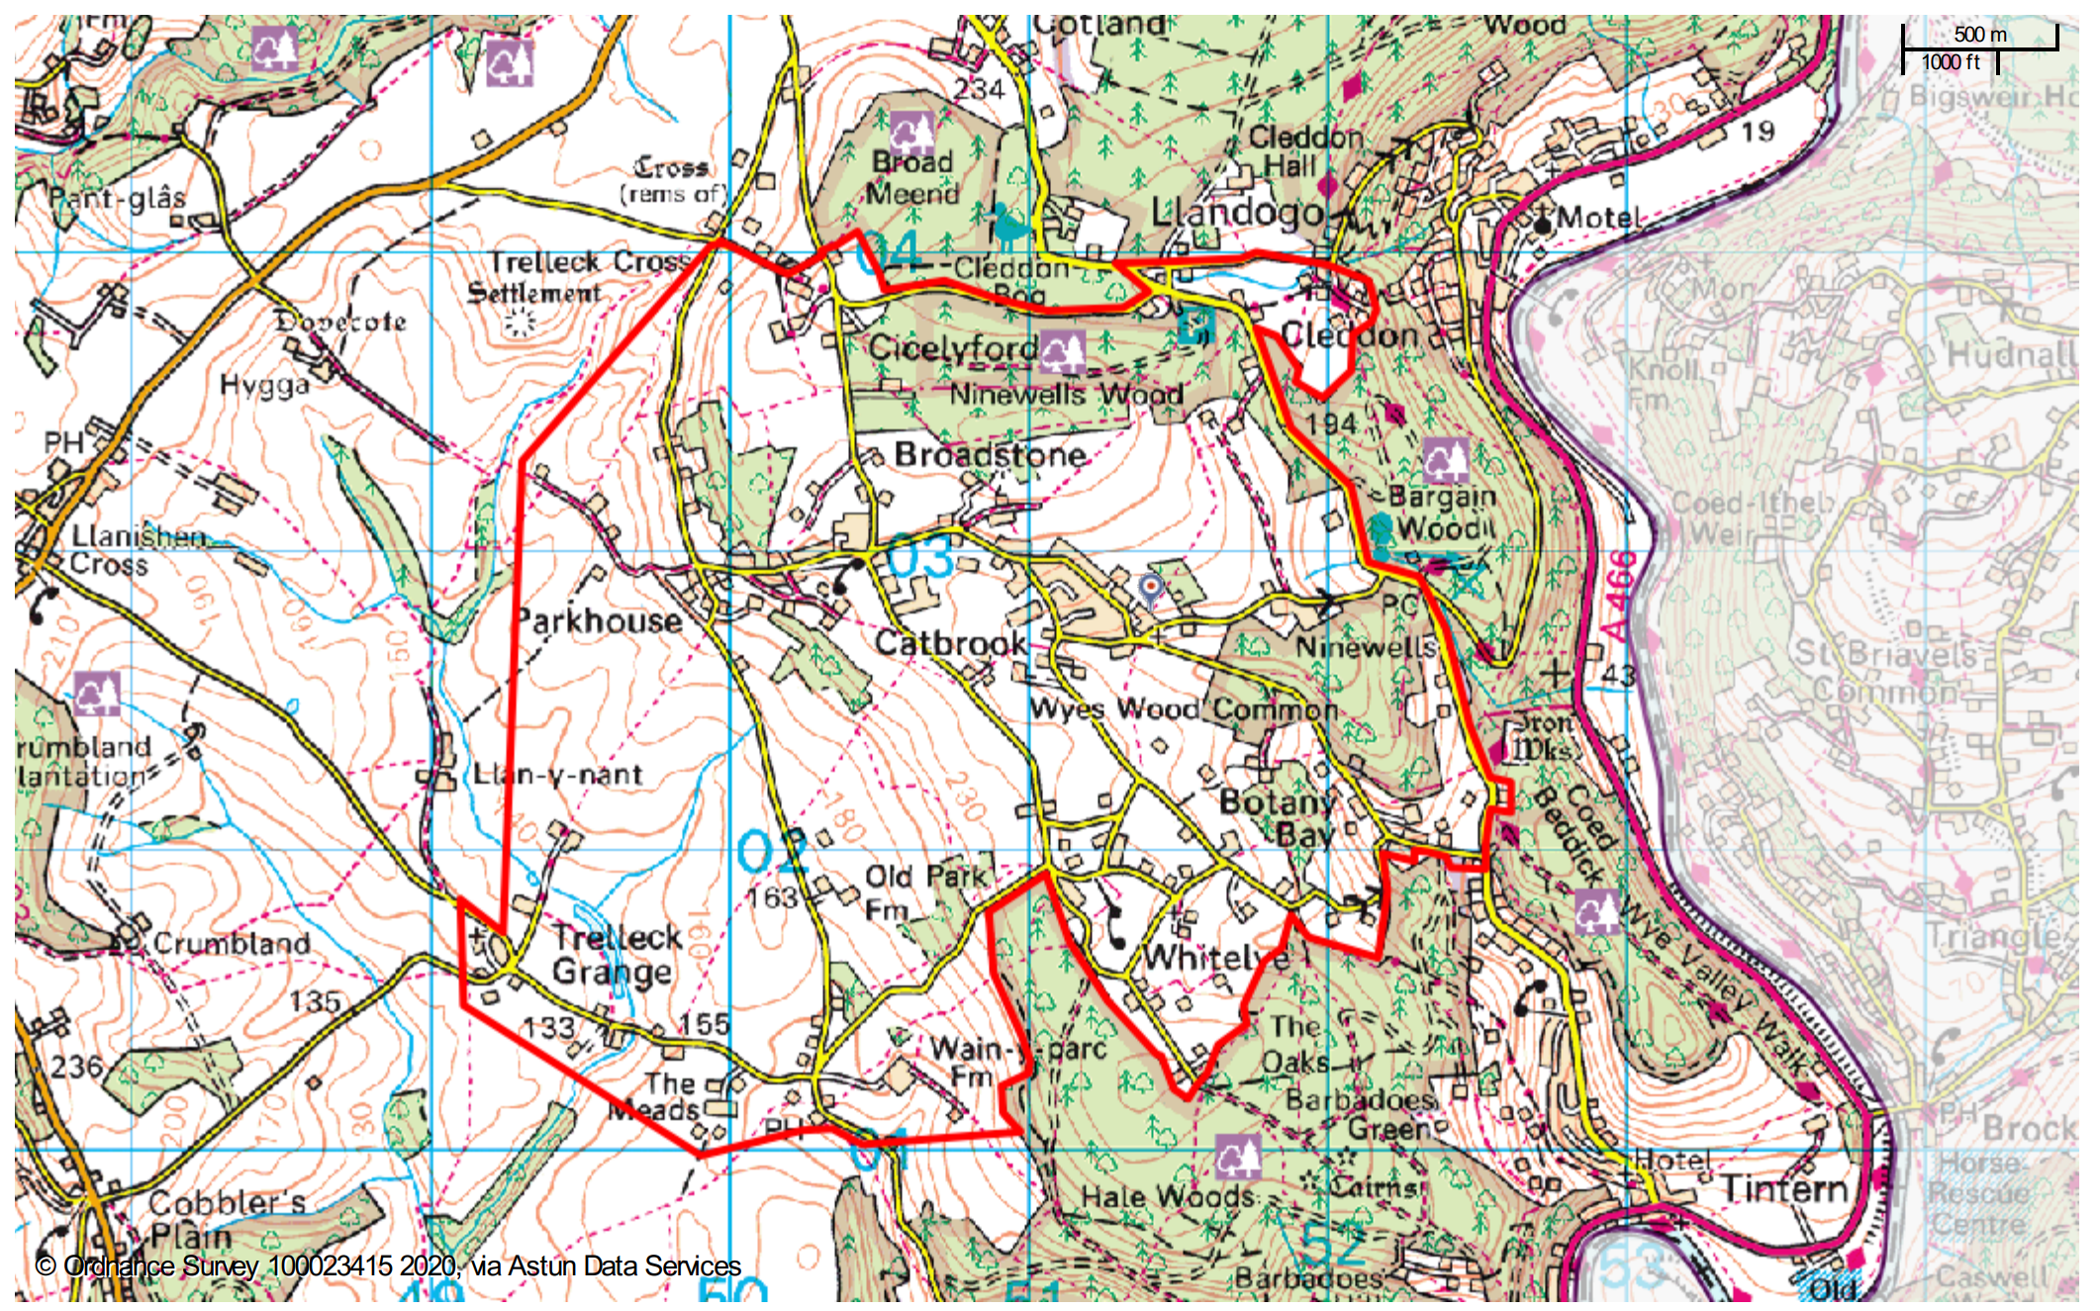
Catbrook Village School Catchment Rationale.
Following extensive research and enquires, to the best of CET knowledge, there is no existing map of the Catbrook village school catchment area. Through historical research, discussions with local residents and the community council, the above proposed catchment area map has been identified and adopted by the Trustees.
Further details regarding the process of establishing the catchment can be obtained on request and the map will be reviewed and adjusted if required.

Annex B - Criteria for the granting of awards
For each request a CET Application Form will be required from the applicant or their family, which may also include a video clip or presentation to the Trustees. An Initial Scoresheet will be completed by a nominated group of Trustees based on the application, for discussion and a decision as to merits to be made by the Trustees collectively. All decisions will be recorded in the minutes.
Allocation of funds will be considered taking into account the following criteria, but recognising that every application is individual and the specific circumstances of each will be carefully considered by the Trustees.
- Purpose: What is the main purpose of the request, for leisure (e.g. sports lessons), personal development (e.g. learning a new skill/outdoor experience/outward bound), schooling or additional tuition (e.g. uniforms, transportation, extra teaching), higher education or improvement of employment prospects such as presentation skills training or community support or development e.g. a project or proposal that will have an impact on the wider community such as a community project/garden/sport/facility/legacy.
- Benefit: How does the request benefit the applicant, for example, special learning or additional learning needs, physical or intellectual improvement (e.g. to purchase books, equipment or learning materials), or learning specific skills e.g. via an apprenticeship. Applications which potentially benefit more than one child in the wider community would be given additional consideration
- Educational Circumstances: Is the applicant currently at school? If so, state or private? If beyond school age, are they employed, apprenticed or at university? Applicants who already benefit from private schooling or are employed would typically be regarded as lower priority.
- Personal circumstances: consideration will also be given to financial hardship or physical/mental disability or with additional learning needs
- Previous claims: there is no specific limit on the number of claims per applicant or family, but those who, either individually or as a wider family, have been awarded previous grants would be regarded as lower priority than those who have not.
- Age: Age is not a primary consideration other than the upper age limit of 25 years. Babies and children under 3 are likely to be considered a lower priority.

Catbrook Educational Trust
Application for Grant
Personal Details
Name of person to benefit (Applicant):
Age of Applicant:
Date of Birth:
Name of Parent / guardian:
(if Applicant is under 18 years old)
Address:

I / we have been resident in the catchment area | From: | To:
How would you like us to contact you? | Mobile: | Email:
Is the Applicant in school / college or employment? Please provide details
Applicant’s Personal Statement
This is an opportunity for the applicant to tell us about yourself, the things you are passionate about, and your aspirations. Please provide detailed information and take as much space as needed
What do you want to do, and why?
What do you want to do?
For example, a training course, lessons, tuition, outdoor experience, purchase of books or equipment etc. Provide as much detail as possible in one paragraph.
How will this benefit you?
Explain the benefit you will get from this, e.g. personal development, improved education or employment prospects, physical or mental health benefit etc
How will this benefit the local community?
If this will provide benefit to the local community, please explain in one paragraph
Financing
How much will this cost?
Do you have or are you seeking money for this from other non-family sources, and if so, how much?
How much financial support are you requesting from CET?
Have you or your immediate family received money from CET previously? | Please provide details of benefit previous grant provided (see note below)
Would you describe your family as less affluent? | Yes / No (see note below)
How did you hear about the Trust? | Word of mouth / Catbrook Email / poster / flyer / other
Feedback
Would you be happy to tell people about your experience at the CET Annual General Meeting | Yes / No (see note below)

Application Form Completion Date: _______________________________
Notes on completing this form:
- The objective of the Catbrook Educational Trust (CET) is to promote the education (including social and physical training) of persons who are under the age of 25 and are or have been resident in the catchment area of the former Catbrook School. The catchment area is detailed on our website.
- CET expect that
  - For applicants in Primary School and younger, parents or guardians will complete the application form. However, the committee would welcome application forms completed wholly or in part by the young person themselves.
  - For applicants in Senior School, the applicant will complete the application form with support from parents or guardians
  - For applicants in Sixth Form, in college or in employment, the application form will be completed by the applicant.
- The “Personal Statement” and “What do you want to do, and why” sections should be completed in writing using this form. If you would like to add weight to your application by including a more personal presentation of this information, either in the form of a video clip, or a face to face presentation the committee would welcome that. If you wish to take advantage of this opportunity, please send the video clip, or let us know in your email. If the applicant is under 18 years old, they must be accompanied by a parent or guardian for any face to face meetings.
- CET would welcome feedback from the applicants on the benefit that they derived from their experience. We envisage this to be at the Annual General Meeting. We would want to ensure that this feedback is provided in a way that the applicant is comfortable with, and is appropriate to their age. This could take the form of an informal chat, a video clip, a letter, or a presentation.
- The completed application form should be emailed to the Secretary before the Application Closure Date, as per details on the address on the website.
- If you wish to provide a video clip, please attach it to your email. If you wish to take advantage of a face to face meeting, please let us know in your email, and we will be in contact to arrange a date.
- The completed application form will be treated as confidential, and will only be seen by the Trustees of the CET. If the Trustees are not sufficiently knowledgeable to make a decision, then in these exceptional circumstances, the application form may be shared with any expert called upon to advise the Trustees.
- By submitting this form you consent for the CET to store your personal details.
  - The name of the person benefiting, their address, the amount of money awarded, and what it was provided for will all be stored for the period of time required by the Charity Commission.
  - Email addresses and mobile phone numbers will be deleted shortly after the AGM after completion of the event.
- CET is particularly keen to provide grants to less affluent families in the catchment area. If you feel that this is relevant to your application, then please either
  - Include a brief covering letter with your application form explaining your situation, which will be kept confidential and reviewed by only one member of the committee, or
  - If you’d prefer not to have such matters put into writing, add a note to your application form asking one of the trustees to contact you. That person can listen to your view, which he or she will then use to determine the appropriate scoring for your application. This will be in confidence, and only the final scoring will be discussed by the committee.
We hope that in either of these ways applicants will be confident that their confidentiality will be respected.
- If you’ve received a previous grant, please provide detail of what the previous grant was for, and the benefit it provided. Please be as specific as possible, and if possible provide photos or similar that can be displayed to the wider community (eg via a board at the village hall).

Annex C - Annual Timetable
The annual timetable is as follows:
February/March | Trustee Board meeting to plan communication of next application round
April | Approval of Accounts at end of Financial year  Communication regarding current year process  Applications open
June | Applications close
July | Trustee Board meeting  Applications assessed and grants awarded  Grant confirmation letters sent to individuals
August | Payment of grants to individuals
September/October | Annual General Meeting  Opportunity for recipients to present feedback  Report to TUCC  Update website
November or January | Trustee Board meeting (optional)

