
Supporting local children and young people with learning and development grants
Annual Report - 2025
Background
In 1997 the old Catbrook school building and grounds were sold with the proceeds of the sale going to Newport County Borough Council. After a protracted period of work and considerable perseverance by TUCC Councillors, Duncan Myatt and Martin Routh, the proceeds of the sale, and the interest earned in the interim, were secured and the Catbrook Educational Trust (CET) was set up in 2004 with funding of an initial sum of £136,139.75. The Trust was set up with the aim of supporting the education and personal development of young people under the age of 25, who are or have been resident in the catchment area of the former Catbrook School. This area includes the villages of Catbrook, Broadstone, Whitelye, Parkhouse, Cicelyford, Trellech Grange and Botany Bay. The Catbrook Educational Trust is a registered charity (no. 1199479) and has formal legal standing. A new board of Trustees was put in place (3 nominated by TUCC and 5 co-opted from expressions of interest from the catchment area) and the CET was relaunched publicly in 2021. Since we relaunched the Educational Trust 5 years ago we have provided 122 grants to 50 children and young people and 2 community projects focused on children. We have distributed £25,570.89 in grant funding to support the education and personal development of children and young people in the local area. We have also been privileged to see and contribute to the great breadth of interests, activities, learning and experiences that local young people are involved in.

2025 Application Round
Meetings
The Trustees have met 3 times during the 2025 applications round. All meetings have been quorate, written agendas circulated in advance of the meeting and full minutes have been taken at each one (minutes and agendas available to view on request). The Governance procedures for the Trust require at least 2 meetings per year.
Date | Purpose | Venue | Attendance
6th November 2024 | AGM All Trustees | The Fountain Inn | Apologies from NW. LT
2nd April 2025 | Ordinary meeting all Trustees | The Lion Inn | Apologies from AP, NW
23rd July 2025 | Ordinary meeting all Trustees | Catbrook Village Hall | Apologies none

The key actions carried out by Trustees during 2025 Applications round.
- Investments – Monitoring of investments
- Review of Operation – Trustees carried out a reflection and review exercise of all process and communications following the fourth round of grant applications. This included reviews and amendments to the criteria, scorecard, Charter and Application form
- Village Hall Display – Trustees have updated the display of information about the Educational Trust and feedback from some of the beneficiaries in the form of pictures/letters on a notice board in Catbrook village hall.

Applications
Applications opened on Monday 28th April 2025 and closed on Monday 16th June 2025. Trustees communicated application timings and process via the Catbrook village Hall website, email database, Facebook page, and posters throughout the catchment area. All applications were acknowledged. Applications were scored and discussed at an Ordinary Trustee meeting on 23rd July 2025. Letters were sent to each applicant explaining that they had been successful, giving them the amount of the grant that they would receive and asking for bank details and feedback on the contribution that the grant has given to each applicant. All grants were paid in August 2025. We received 25 applications in total from children and young people in the catchment area. All applications were successful and the Trustees awarded grants to the total of £4,271.

Analysis

Application analysis 2025 |  | Applications were received from or on behalf of 25 children and young people
Applied before
Received grant before | 20
First application | 5
Less Affluent
No. describe themselves as less affluent | 4
Age
Pre-School 0-5 | 1
Primary 5-11 | 6
Secondary 11-16 | 10
Sixth Form 16-18 | 3
Higher and post Education | 5
Community group | 0
Total | 25
Type of Activity
Lessons | 5 | Swimming , Driving, Riding,
Equipment | 10 | School/University, Technology, Books, Sports
Transport | 2 | Bus and Rail passes
Training | 2 | University, Diving
Experiences | 6 | Club memberships, Sports, Travel, Theatre
Learning need | 0
Community/group | 0
Total | 25
Grant amounts split %
Lessons | 18%
Equipment | 39%
Transport | 3%
Training | 11%
Experiences | 29%
Learning need | 0
Community/group | 0
Total | £4,271

Applications by Age
2021 - 2025
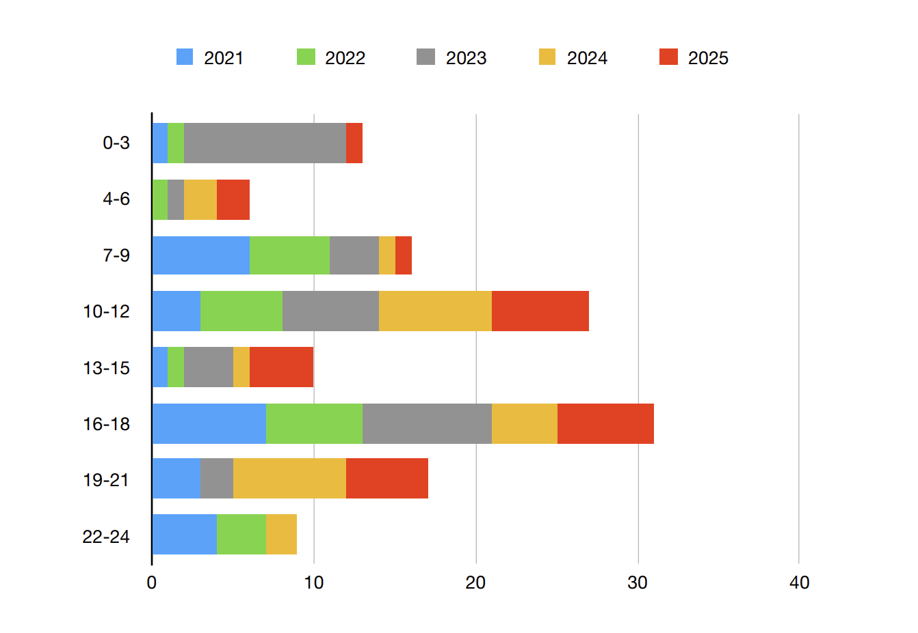
Applications by Education
2021 – 2025

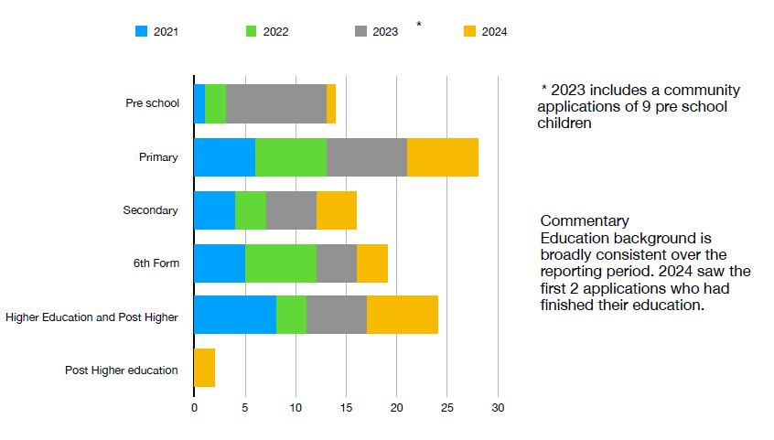

Applications by Activity
2021 - 2025

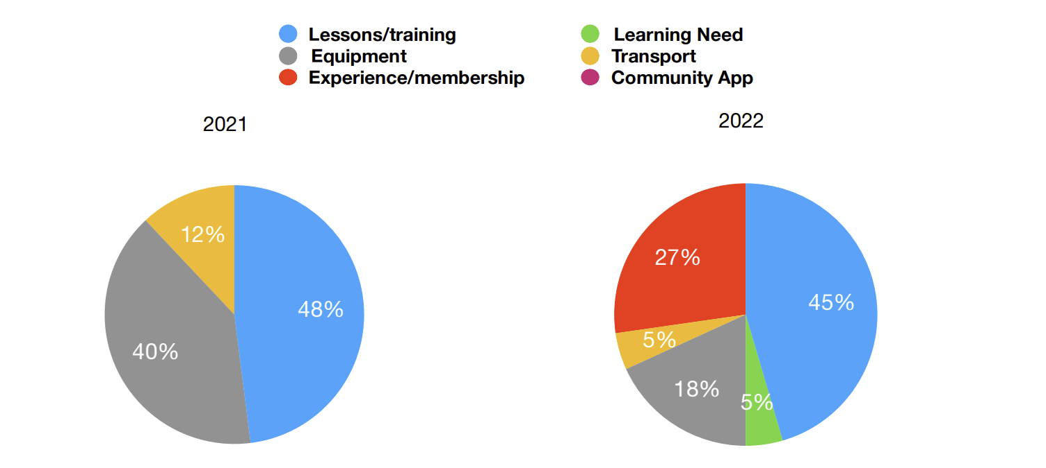
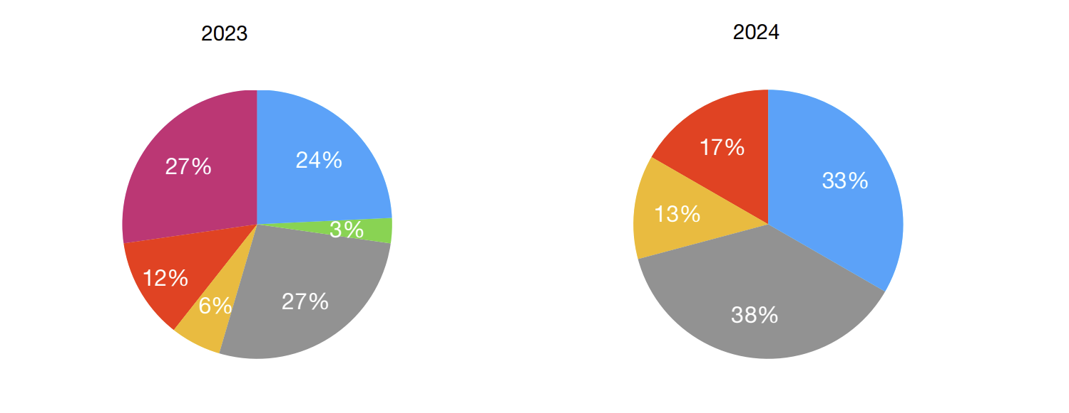
2025
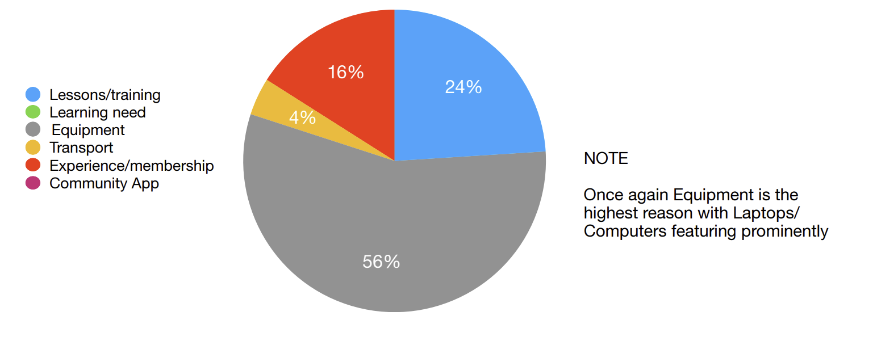
Frequency of Application and Affluence
2021 - 2025

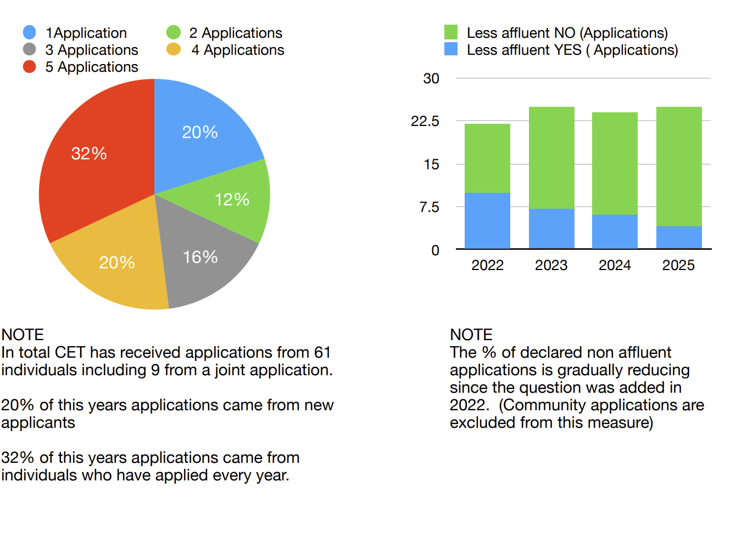
Next Actions
- Reflection and review following the fifth round of grant applications including processes, charter, governance doc, application form, score card and criteria, and communications
- Increase feedback showing the contribution CET has made to the children and young people of the area and ways to display this in the village hall and on the webpage. Send email to applicants just before the next round opens to ask for feedback.
- Updates to the web page with news from the fifth round of applications
- Develop and publish of the timeline and dates for the next round of applications in 2026.
- Monitoring of fund investments and look for options to replace Cambridge and Counties Fixed rate bond which matures in May 2026
- Identification and communication of other avenues for funds for families in need so that we are also able to help people in the catchment area access these.
- Explore viability and ideas for fundraising to increase the CET fund and ensure its sustainability.

Accounts (as at 31.3.25)
Trustees can spend expendable income and, if considered applicable, the expendable endowment, to support the aims and objectives of the Trust. The Trustees are mindful of the importance of ensuring that the distribution of funds will be sustainable into the future. Therefore, Trustees set an upper limit, with some flexibility, on the amount of funds that can be distributed each year. The accounts for the Trust are published annually on the CET webpage.
Income and Expenditure Summary
Funds arising
Proceeds from sale of school (Permanent Endowment) | £116,133.76
Interest earned before transfer (1997-2004) – Expendable Endowment | £20,005.99
Funds transferred from MCC 2004 (CET inception) | £136,139.75
Increase in funds between 2004 and July 2020 (expendable funds at Re-launch) | £33,189.38
Interest earned since re-launch | £11,446.45
Admin costs to 31.3.20 | -£27.70
Grants paid 2021 | -£4,901.00
Grants paid 2022 | -£4,634.00
Grants paid 2023 | -£4,824.89
Grants paid 2024 | -£4,940.00
Grants awarded, not yet paid to 31.3.25 | -£2,000.00
Expendable Funds at 31.3.25 | £159,447.99
Funds held as Cash/Bank Investments
Treasurer’s Account (Lloyds) | £0.90
Instant Access Account (Lloyds) | £6,447.09
Cambridge and Counties fixed rate bond (set up 12.5.23) | £75,000.00
United Trust Bank base rate tracker account (set up 12.6.23) | £80,000.00
Grant awarded not yet paid | -£2,000.00
Expendable Funds at 31.3.25 | £159,447.99

Operation of the Trust - Key Aspects
Catchment Area
The Trust relates to any young people under the age of 25 who reside or have resided in the catchment area of the old Catbrook School. In order to determine the extent of the catchment area the Trustees consulted previous Trustees, former pupils of the Catbrook School and local residents. We also looked at village maps and the TUCC electoral area. The catchment area map can be viewed at www.catbrook.org.uk/catbrook-education-trust.
Charter
Trustees have agreed to a Charter, based on the Governance document. The Charter makes it clear to local residents how the CET will operate. It covers the purpose, Trustees, Activities, duties and responsibilities, catchment area, criteria for granting of awards, and application form.
Score card and Criteria to Distribute Funds
Trustees have agreed the criteria for distributing funds in the form of a scorecard to measure applications against and ensure that each application is judged fairly and objectively. The scorecard has been reviewed annually following each application round to ensure that it delivers against the core objectives of the Trust. The agreed criteria take into account the purpose of the application, the benefit to the applicant, the educational, personal and financial circumstances of the applicant and any claims made in the past. The criteria for the distribution of funds can be seen in the Trust Charter on the CET web page.
Communications
Trustees communicate with residents via:-
- A dedicated webpage on the Catbrook Memorial Hall website www.catbrook.org.uk and information posted to the home page when required
- Flyers distributed to all households in the catchment area as required
- Posters in prominent positions throughout the catchment area
- Email to all residents registered on the Catbrook Village Hall email database (circa 200)
- Posts on the Catbrook village Hall Facebook page as required.
Trustees
Details of the Trustees and biographies can be seen on the CET web page at https://www.catbrook.org.uk/catbrook-education-trust.
Terms of office are 4 years
Appointed Trustees | Role | Co-opted Trustees | Role
Andy Pullan |  | Laura Thorpe
Nicky Harvey |  | Dawn Cater | Treasurer
Leanne Wakerley | Chair | Craig Bridgeman
 |  | Nigel Williams
 |  | Dave Phipps

Leanne Wakerley – Chair on behalf of Catbrook Educational Trust Trustees November 2025

