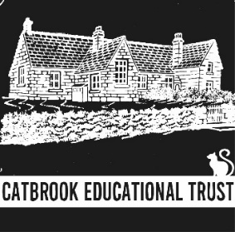
Supporting local children and young people with learning and development grants
Annual Report
2023
Background
In 1997 the old Catbrook school building and grounds were sold with the proceeds of the sale going to Newport County Borough Council. After a protracted period of work and considerable perseverance by TUCC Councillors, Duncan Myatt and Martin Routh, the proceeds of the sale and the interest earned in the interim were secured and the Catbrook Educational Trust (CET) was set up in 2004 with funding of an initial sum of £136,139.75. The Trust was set up with the aim of supporting the education (including social and physical training) of young people under the age of 25, who are or have been resident in the catchment area of the former Catbrook School. This area includes the villages of Catbrook, Broadstone, Whitelye, Parkhouse, Cicelyford, Trellech Grange and Botany Bay. The Catbrook Educational Trust is a registered charity (no. 1199479) and has formal legal standing. A new board of Trustees was put in place (3 nominated by TUCC and 5 co-opted from expressions of interest from the catchment area) and the CET was relaunched publically in 2021. In the first two rounds (2021 & 2022) 56 grants were made to children and young people in the catchment area; totalling £9535.
Key Aspects of Operation of the Trust
Catchment Area
The Trust relates to any young people under the age of 25 who reside or have resided in the catchment area of the old Catbrook School. In order to determine the extent of the catchment area the Trustees consulted previous Trustees, former pupils of the Catbrook School and local residents. We also looked at village maps and the TUCC electoral area. The catchment area map can be viewed at www.catbrook.org.uk/catbrook-education-trust.
Charter
Trustees have agreed to a Charter, based on the Governance document. The Charter makes it clear to local residents how the CET will operate. The Charter is available to view at www.catbrook.org.uk/catbrook-education-trust and covers the following areas:
- Purpose
- Trustees
- Activities, duties and responsibilities
- Catchment area
- Criteria for the granting of awards
- Application Form and notes for completing the form
Score card and Criteria to Distribute Funds
Trustees have agreed the criteria for distributing funds in the form of a scorecard to measure applications against and ensure that each application is judged fairly and objectively. The agreed criteria take into account the purpose of the application, the benefit to the applicant, the educational and personal circumstances of the applicant and any claims made in the past. The criteria for the distribution of funds can be seen in the Trust Charter on the CET web page.
Communications
Trustees communicate with residents via:-
- A dedicated webpage on the Catbrook Memorial Hall website www.catbrook.org.uk and information posted to the home page when required
- Flyers distributed to all households in the catchment area as required
- Posters in prominent positions throughout the catchment area
- Email to all residents registered on the Catbrook Village Hall email database (circa 200)
- Posts on the Catbrook village Hall Facebook page as required.
Trustees
Details of the Trustees and biographies can be seen on the CET web page at https://www.catbrook.org.uk/catbrook-education-trust.
Terms of office are 4 years
Appointed Trustees | Role
Andy Pullan
Nicky Harvey
Leanne Wakerley | Chair
Co-opted Trustees
Laura Thorpe
Dawn Cater | Treasurer
Craig Bridgeman | Secretary
Nigel Williams
Dave Phipps

Meetings
The Trustees have met 3 times during the 2022/23 applications round. All meetings have been quorate, written agendas circulated in advance of the meeting and full minutes have been taken at each one (minutes and agendas available to view on request). The Governance procedures for the Trust require at least 2 meetings per year.
Date | Main agenda items | Venue | Attendance
21st September 2022 | Ordinary meeting and AGM All Trustees | Meadow House | Apologies from NH
5th April 2023 | Ordinary meeting all Trustees | Meadow House | Apologies from CB
19th July 2023 | Ordinary meeting all Trustees | Catbrook Village Hall | No Apologies

Accounts
Trustees can spend expendable income and, if considered applicable, the expendable endowment to support the aims and objectives of the Trust. The Trustees are mindful of the importance of ensuring that the distribution of funds will be sustainable into the future. Therefore Trustees set an upper limit, with some flexibility, on the amount of funds that can be distributed each year. The accounts for the Trust are published on the webpage annually at CET webpage.
Income and Expenditure Summary
Proceeds from sale of school (Permanent Endowment) | £116,133.76
Interest earned before transfer (1997-2004) – (Expendable Endowment) | £20,005.99
Funds transferred from MCC 2004 (CET inception) | £136,139.75
Increase in funds between 2004 and July 2020 (expendable funds at Re-launch) | £33,189.38
Interest earned since re-launch | £2,516.99
Admin cost to 31.3.20 | £27.70
Grants paid 2021 | £4,901
Grants paid 2022 | £4,634
Expendable Funds at 31.3.23 | £26,143.67
Cash/Bank Investments
Treasurer’s Account (Lloyds) | £0.90
Instant Access Account (Lloyds) | £7,282.52
Cambridge and Counties fixed rate bond (set up 12.5.23) | £75,000
United Trust Bank base rate tracker account (set up 12.6.23) | £80,000
 | £162,283.42

Key actions this year
The key actions carried out by Trustees during the year 2022/2023.
- Investments – The bulk of the funds was split between two investment products in separate banks to ensure that the trust can take advantage of protections offered by banks and of raised interest rates on savings – see above for details.
- Review of Operation – Trustees carried out a reflection and review exercise of all process and communications following the second round of grant applications. This included reviews and amendments to the Charter, Application form, Catchment area, Communications to residents, Score card and distribution criteria.
- Village Hall Display – Trustees have developed a display of information about the Educational Trust and feedback from some of the beneficiaries in the form of pictures/letters on a notice board in Catbrook village hall.
2023 Applications round
Applications opened on Monday 17th April 2023 and closed on Friday 16th June 2023. Trustees communicated application timings and process via the Catbrook village Hall website, email database, Facebook page, flyers to each household and posters throughout the catchment area. Applications were scored and discussed at an Ordinary Trustee meeting on 19th July 2023. Letters were sent to each applicant explaining that they had been successful, giving them the amount of the grant that they would receive, asking for bank details by the end of July and asking for feedback on the contribution that the grant has given to each applicant. All grants were paid by mid-August 2023. We received 25 applications in total from or on behalf of 33 children and young people, all of which were successful, and awarded grants to the total of £5,825, including a contribution to a group application that, in partnership with the Trellech United Community Council, will benefit many children in the catchment area.
Analysis shows the gender split was virtually equal and this was the same for applicants who have applied before versus those have not. This year shows a marked increase in applications from younger children with 19 out of 33 applicants being of pre-school or primary school age, 5 secondary and 10 sixth form and above. Just under a third of applications (9) were from families who would describe themselves as less affluent. There was one application from a group of families to support improvements to play equipment in the village that will benefit many families in the area.

Application analysis 2023 |  | Applications were received from or on behalf of 33 children and young people
Applied before
Received grant before | 17
First application | 16
Less Affluent
No. describe themselves as less affluent | 9
Age |  | Main activities applied for
Pre-School 0-5 | 11* | Play equipment for village, singing
Primary 5-11 | 8 | Lessons, computer equipment,
Secondary 11-16 | 5 | Lessons, sports equipment, Experiences
Sixth Form 16-18 | 4 | Lessons, experiences, computer equipment
Higher and post Education | 6 | Computer equipment, experiences,
Total | 33
 |  | *Includes 9 children whose parents applied together for a community project
Type of Activity
Lessons | 8 | 4 swimming , 2 music, 2 homeschooling
Equipment | 9 | 6 laptops, 1 other technology, 1 music, 1 sport
Transport | 2 | 2 driving lessons
Training | 1 | Rowing
Experiences | 3 | 1 school trip, 2 Rowing
Learning need | 1
Community/group | 1
Total | 25
Grant amounts split %
Lessons | 32%
Equipment | 37%
Transport | 8%
Training | 8%
Experiences | 9%
Learning need | 6%
Community/group | 17%
Total | £5,825 ** | **including £1000 grant for the group application

Graphs

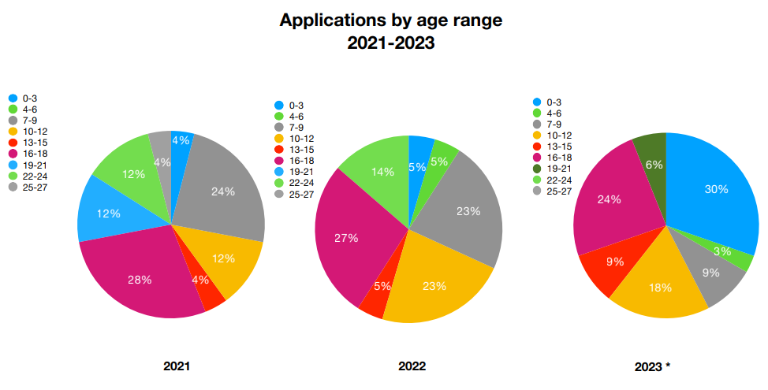
* note 2023 includes Community application of 9 children aged 0-3

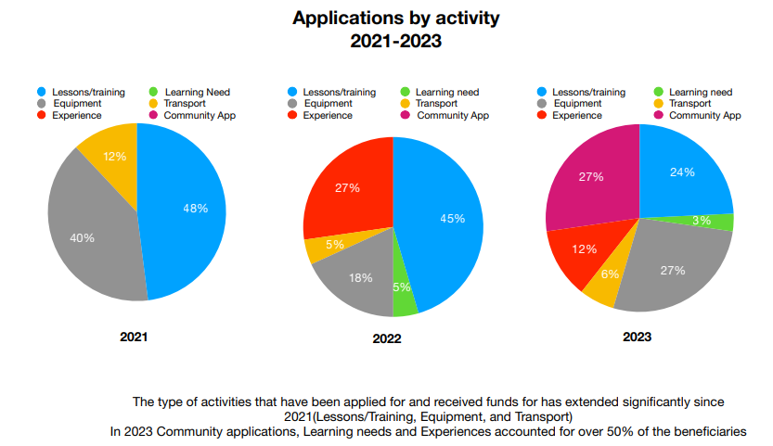
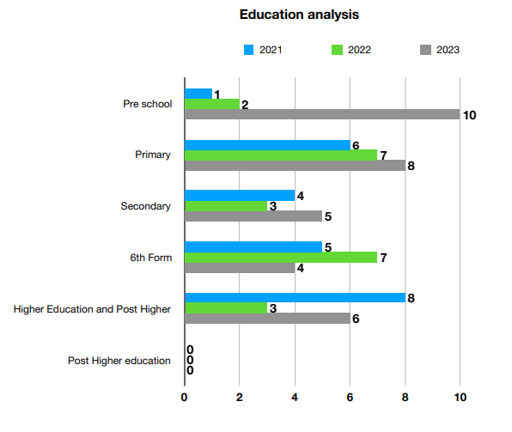
* note 2023 includes Community application of 9 children aged 0-3

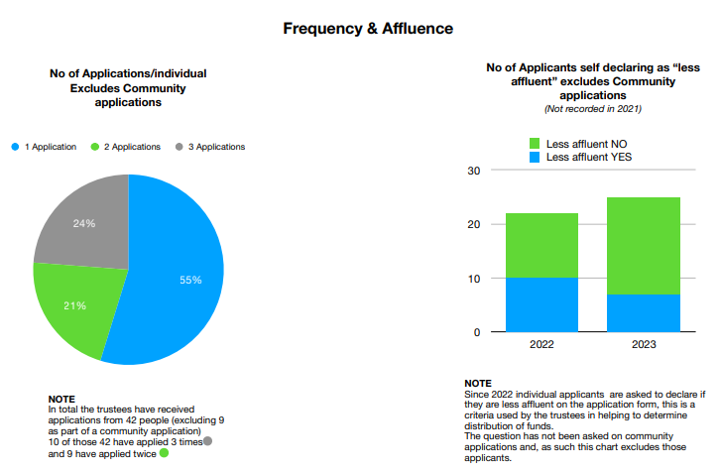
Next Actions
- Reflection and review following the third round of grant applications including processes, charter, governance doc, application form, score card and criteria, and communications
- Increase feedback showing the contribution CET has made to the children and young people of the area and ways to display this in the village hall and on the webpage.
- Updates to the web page with news from the third round of applications
- Development and publication of the timeline and dates for the next round of applications in 2024.
- Monitoring of fund investments. Develop and approve fund management and investment policy document
- Identification and communication of other avenues for funds for families in need so that we are also able to help people in the catchment area access these.
- Produce a formal Data protection policy
- Explore viability and ideas for fundraising to increase the CET fund and ensure its sustainability.

Leanne Wakerley - Chair
On Behalf of Catbrook Education Trustees
September 2023

